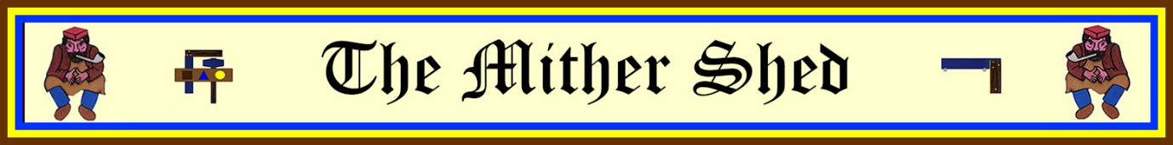

A BRIEF INTRODUCTION TO THE SQUAREMEN

Ye Corporation O’ Squaremen was originally formed as an Operative Lodge in Ayr, and according to the legends and rituals of the order it formed one of the number which constituted the Grand Lodge of Ancient and Accepted Freemasons of Scotland in 1736. It has since evolved into a fun or side degree which raises money for local charities.

The legends of the order also state that minutes were kept but have since been lost and that the Banner used by the Corporation is still preserved by an Ayrshire Freemason and that there are other relics in existence.

20th Century Formation

In 1903, the organization was re-formed in Edinburgh by Brothers Philip and William Murray. It spread across Scotland and England but became less popular after World War II. Although not recognised or in amity with the Grand Lodge of Scotland, the candidate must be a regular mason, and many eminent masons are Square Men.

There is a degree ceremony and secrets are imparted, but the main purpose is to raise funds for local good causes and charities.

Initially the Squaremen only admitted Mark Master Masons who hold or have held office in a Craft Lodge, or who are Royal Arch Companions. Candidates must have been Master Masons for at least five years and be thirty years of age or over.

The first Squaremen meetings were held in Edinburgh on the first day of each of the five winter months, November to April, and at the January meeting office bearers were elected. A meeting of Squaremen is called a Shed as opposed to a Masonic Lodge, and a Grand Shed was formed to oversee the Order. At its prime, there were 12 daughter Sheds in existence and these Sheds met fairly regularly and in masonic halls, usually varying their venue each time. The joining fee was originally 60 Scottish merks (£3/5/0 or about £15.75).

The Order today.

In the early 21st Century, the order consists of eight working Sheds in Scotland and one in England, each responsible for raising money for local charities, with children’s charities being the main beneficiaries selected by the Squaremen of each shed.